Peace Summer Day Camp 2017
We’ve got an awesome Peace Day Camp planned this year! We’re bringing back a few favorite activities, and we’ll all try something new, as well! Please note: the July dates are confirmed, but the activities planned for each day are somewhat tentative and weather dependent. (Last year, we went swimming on the one cold, rainy day of the week!) Any last minute changes will be well communicated.

Peace Day Camp is open to anyone eight years or older who attends Peace Church or is a friend or guest of a Peace Church member. Please contact the church office via phone or email to register your child for Peace Camp to help us in our planning. Children are encouraged but do not need to attend every day if family or previous commitments are conflicting.
Tuesday, July 18  Morning: Create and deliver a special gift for our Peace homebound members. Our recipients greatly appreciate this yearly tradition!  Lunch: at the church  Afternoon: Begin to plan and build your own Cardboard Arcade game! Need: one cardboard box and your creativity!  cainesarcade.com  We will have plain masking and duct tape. If you want “fancy” tape, feel free to bring what you like! | Wednesday, July 19  10:00 Movie Morning:  The Trolls movie will be playing at Cedar Creek Cinema! Admission costs have been covered by a congregation member! Kids should bring $2.75 for popcorn/drink. Kids may bring extra $$ for another snack item. (9:30 departure & 11:45 return)  Lunch: at the church  Afternoon: Craft project for the Annual Church Bazaar  Continue work on arcade games.  Strawberry Shakes for an afternoon snack! | Thursday, July 20  Morning: Games and crafts at the church  Lunch: at the church at 11:15  12:00 Rock Wall Climbing at Greenheck Fieldhouse. Challenge by choice - climb to the height that you are comfortable and able! Climb up to 30 feet! 8 years old and up is the facility policy. No flips flops or sandals for climbing. Admission costs have been covered by a congregation member! (11:40 departure)  1:30-2:50 Ice Skating at Greenheck: Bring warm clothes! You’ll greatly appreciate a sweatshirt, long socks, and gloves or mittens to don when inside the rink! $3.00 admission  $3.00 skate rental | Tuesday, July 25  Morning: Rib Mountain State Park: Hike the hill, climb the tower, and leave the park a little cleaner than we find it.  (9:30 departure)  Lunch: Picnic lunch on top of the mountain!  Afternoon:  The Peace Day Campers have always loved visiting the Rib Mt. Bowmans’ Club! Costs have been covered by a congregation member! (3:30 return)  Ready… Aim… Shoot!  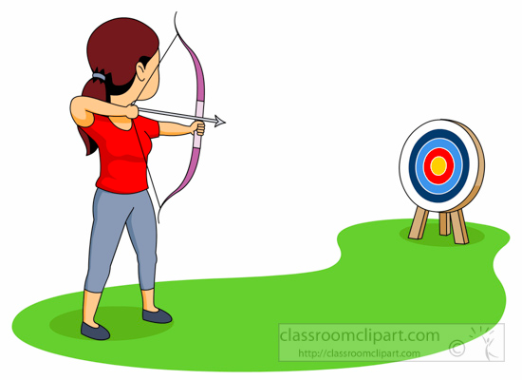 | Wednesday, July 26  Morning: Food prep for evening cook-out! Finalize and set up Cardboard Arcade  Lunch: at the church at 12:00  Afternoon: Pool Party at Rothschild Aquatic Center. $2.00 admission plus $3-$5 to purchase afternoon snacks (1:00 departure & 3:30 return)  New This Year!  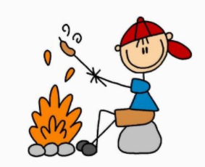  Families and congregation members: please join us for a traditional campfire cookout 5:00 to 6:30 p.m. with a brief vesper service at 6:30 around the campfire in the church yard.

